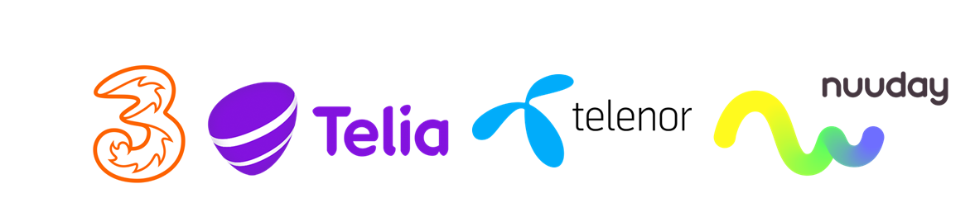 | Application form for pre-approval of SMS SENDER ID  Nuuday, 3, Telenor, Telia

Please complete this form and return it to either Nuuday, 3, Telenor or Telia depending on your preferred partner, to start the pre-approval application.

Notes
- Applications can take up to one week to process
- If your application is approved, you must contact each operator individually for signup/setup process

REQUESTED SENDER ID
SENDER ID
  1 | 2 | 3 | 4 | 5 | 6 | 7 | 8 | 9 | 10 | 11
Optional “lookalike”
  1 | 2 | 3 | 4 | 5 | 6 | 7 | 8 | 9 | 10 | 11
Optional “lookalike”
  1 | 2 | 3 | 4 | 5 | 6 | 7 | 8 | 9 | 10 | 11
Optional “lookalike”
  1 | 2 | 3 | 4 | 5 | 6 | 7 | 8 | 9 | 10 | 11
Optional “lookalike”
  1 | 2 | 3 | 4 | 5 | 6 | 7 | 8 | 9 | 10 | 11
Notice | Sender ID must be minimum 3 characters – maximum 11 characters.  Character set is limited to GSM 7-bit – Alphanumeric only  “Lookalikes” must be close lookalikes and not different brand names !

Brand / Company details:
Company Name |  | CVR / VAT#

Company Name

Address
Postal city/town |  |  | Postcode
Contact Name |  |  | Contact E-Mail

Aggregator / Solution partner details:
Company Name |  | CVR / VAT#

Address
Postal city/town |  |  | Postcode

Contact person

Contact Mail

Aggregator confirms to have received LOA | YES (Letter of authority from Brand/Company)

